GOD ́S KALEIDOSCOPE
THE INTERNATIONAL AND ECUMENICAL CALL TO RACIAL JUSTICE
NOVEMBER 8 to 11 2023
HOSTING CITY: FREIBURG IM BREISGAU, GERMANY
CONFERENCE VENUE: HUMBOLDT SAAL
Humboldtstrasse 2, Freiburg im Breisgau, Germany

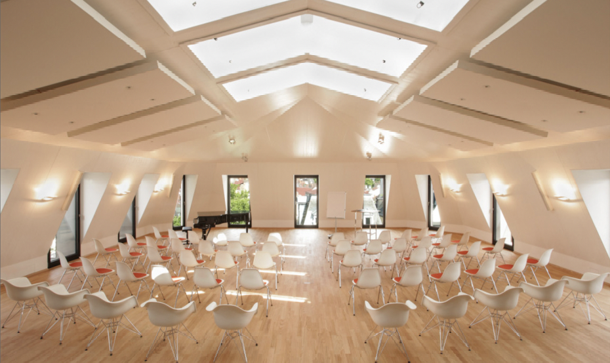

Conference and Accommodation Registration Form
Online submission possible via this link or see Part E

Participants at the conference must be aged 18 or over. However, any younger person can attend with an appropriate/approved chaperone (this information will be shared with the Conference safeguarding team). Participants must arrange their own visas where these are needed. The Conference coordinators will be able to provide letters of invitation once your attendance has been confirmed.

Part A

Family Name

Middle Name

First Name

Age/ Date of Birth

Mobile number with country code

Email for communication

Details of Chaplaincy or Organisation

City and Country of Chaplaincy or Organisation

Details of engagement and interest in the area of Racial Justice

Expected time of arrival in Freiburg

Expected time of departure from Freiburg

Part B - Food and Accommodation
The conference fee is Euros 450 which includes 3 nights hotel accommodation on 8,9,10 November (rooms are held at The Green City Hotel https://green-city-hotel-vauban.de/en/ and The Motel One, Freiburg https://www.motel-one.com/de/hotels/freiburg though there may be other alternatives.
This accommodation is close to the conference venue. Included meals will be:
Hotel breakfast and sandwich lunch on 9, 10, 11 November. Dinner (except drinks) on 9 and 10 November. Separate arrangements will have to be made if extension of stay is planned.

All participants who require the conference to book hotel accommodation are requested to kindly share the following information:

Occupancy preferred (single or twin room)

If a twin room is requested, participants sharing must indicate who the person is that they are sharing the room with.

Would additional night bookings be required? (these are at an extra cost)

Dietary requirements

Any additional information

Emergency contact information (mobile and email)

Participants may arrange their own accommodation but a contribution/registration fee of 100 Euros per person is required to cover lunch on 9, 10 and 11 November plus coffee/tea expenses during the conference. Dinner will be an extra charge.

Bursaries: Funds are being sought for bursaries to help participants who are least able to cover their own costs. If you would like to attend but require bursary support to assist you please give some details of your circumstances here:

Part D - Conference payments
Please submit this form as soon as possible so that arrangements can be put in place in good time. The latest date for registration is September 9, 2023.

As informed in Part B, the costs for accommodation and food are 450 Euros. This amount will need to be paid as soon as possible and by September 1, 2023, at the latest to secure the hotel bookings. However, where possible, please transfer 450 Euros at the same time the registration form is sent.

All payments should be made in-full electronically in Euros at the time of registration to the account below with an email confirmation to the Conference Secretary, Molly Catherine,
Email: freiburgconference2023@gmail.com

Account information: (or other form of payment)
Bank: Commerzbank Bonn
Bank Address: Commerzbank, IN DER SUERST 2 – 4, 53111 BONN
Account name: F.A.C.B.C. e.V. (stands for Friends of the Anglican Chaplaincy Bonn and Cologne)
IBAN: DE56 3804 0007 0255 5571 00
Bank SWIFT ID, if needed: COBADEFFXXX
(all monies paid in must be clearly marked in the section reason for payment 'Racial Justice conference Freiburg')

Part F - Notice
By registering for the conference, participants agree that footage of the conference (Photo, video and/or audio) may be taken, stored and used for legitimate purposes, in particular public relations work and documentation, by the organisers or other participants. Please alert the conference organisers if you have any objection to this.

For participants from outside Germany we recommend to actively ensure that their travel insurances, in particular health, accident and third party liability, cover all potential costs. The organisers’ liability for damage is restricted to intent and gross negligence in exercising their duties.

Part E - Signature

Please forward the completed registration form to the Conference Secretariate at freiburgconference2023@gmail.com at the earliest and not later than September 9, 2023.
It could be submitted online using the link: https://racial-justice-registration-form.odoo.com/survey/start/f0ddf213-88de-4309-b26a-0921530d5522

Notes
- Travel: Freiburg im Breisgau is one of the sunniest, friendliest and greenest cities in Germany. Nearest airport would be Basel or Frankfurt which have frequent bus and train connections. From most cities in Germany there are good train connections to Freiburg.
- Accommodation: will be arranged for participants in hotels near the venue.
- The conference is organized by the Diocese in Europe Racial Justice Working Group: Ms Hureem Salas, Mr Ezekiel Victor, The Revd Canon Smitha Prasadam (until April 2023), Revd Canon Joanna Udal, The Revd Augustine Nwaekwe, The Venerable Dr Leslie Nathaniel (Chair of the Racial Working Group)
- Local Planning Committee Freiburg: Dr Sonia Diaz Monsalve, Mr. Laurence Nodder, Ms. Solveyg Fischer and Dr Gerad Gentry the Church Wardens of the Anglican Church Freiburg, Rev. Andrea Aichelle from the Badische Landeskirche, Rev. Peter Widdess and Revd Vinod Victor - Chaplain of the Anglican Church Freiburg; Mr William Esau and Ms Mirna Maujaes.

Our key partners
The World Council of Churches; USPG-Partners in Global Mission; The Evangelische Landeskirche in Baden – Ökumene und Kirche Weltweit; The Evangelische Landeskirche in Württemberg; The Evangelical Lutheran Church of Finland; The Anglican Church Freiburg.

