The Bishop in Europe:
The Right Reverend Dr. Robert Innes

Dear Brothers and Sisters in Christ,

BISHOP’S ADVENT APPEAL 2019

Anglican Communion Fund - Empowering Women

The Role and Work of the Anglican Communion Fund
My appeal for Advent 2019 is for the Anglican Communion Fund (ACF) – the only Fund I am aware of that specifically supports the mission and work of communities across the Anglican Communion, often in the poorest and most dangerous parts of the world.

In August 2019, Helen and I had the privilege of sharing in a pilgrimage in the Holy Land for bishops and their spouses from across the global Anglican Communion. That experience gave me a renewed vision for the huge potential of the Anglican Communion in a world where so many of our biggest problems, such as climate change, migration and human trafficking involve inter-relationships between people in different countries and continents.

Whilst not a big fund, the ACF tries to deliver maximum impact by working at three levels in the Anglican world:
- Resourcing local projects in line with the 5 marks of mission initiated by churches, and responding to crises;
- Strategic partnerships: working at the level of an Anglican Primate/Archbishop to develop a strategic plan for an Anglican Province;
- Enabling the Anglican Church to be represented in the United Nations, the European Institutions and through the Anglican Centre in Rome.

My appeal focuses on the ACF’s work with empowerment of women, because we know that women often both bear the heaviest costs of poverty or conflict and are also those whose empowerment can do the most to bring development that reaches grass roots and bring hope for the future. The appeal covers the first two levels of ACF’s interests.

- Tanzania Strategic Partnership
The Anglican Church of Tanzania has a vision for spiritual and socio-economic transformation across the country and, with the help of ACF funds, they are rolling out a Church and Community Mobilisation Programme (CCMP) in over 20 dioceses. CCMP uses Mothers Union Bible Study groups to help people bring positive change to their families and communities.

Village and Community Banks enable group members to contribute towards and receive micro-loans to help them create businesses.

Safiya Nyirongo CEO of the ACF writes:
‘Through CCMP women from Central Tanganyika [have not only become self-supporting but] are also helping others to meet their basic needs, providing food and contributing to school fees. Essentially, through participation in this programme, they have become their own group of charitable donors.’ (photos below)

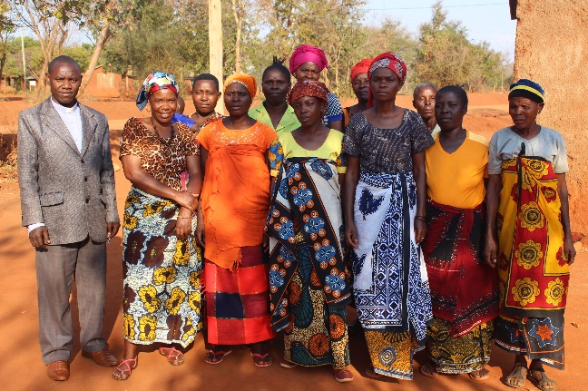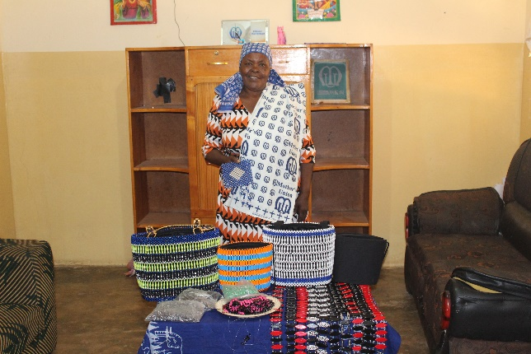

- Women on the Frontline
‘
Women on the Frontline’ is a programme designed for senior Christian women, usually wives of bishops, in areas affected by violence, conflict and poverty, bringing them together on retreat and giving practical training in reconciliation. The programme is led by Mrs. Caroline Welby, wife to Archbishop Justin Welby, and by Mrs. Sarah Snyder, the Archbishop’s Advisor on Reconciliation.

In many parts of the Communion, bishops’ wives are thrust into an important role as the ‘Mother’ of the diocese and are expected to provide leadership to women in the church. Unlike their husbands, who will have had some training for their roles, these women are very often unskilled and undereducated for the role they find themselves in. They need encouragement and equipping to carry out their role with confidence.

Safiya Nyirongo:
- ‘Women sometimes come into the training worn down and burdened by the expectations placed on them, as well as their experiences of conflict. They may have been forced to leave their community or may be living alongside deeply traumatised women without knowing how to support them. They may be discouraged. However, they often come out of the programme full of hope and a sense of possibility, and sensing solidarity with other women. They feel they are loved and called into their role and that they can make a positive impact.’
Every ‘Women on the Frontline’ programme reaches about 20 women directly. Each of these women take their learning and experience back to their communities. If each reaches a further 10, then 200 women are impacted.
Four programmes have now been run – in South Sudan, Burundi, the Solomon Islands (pictures below), and DRC. Further programmes are planned in the Middle East and Pakistan.

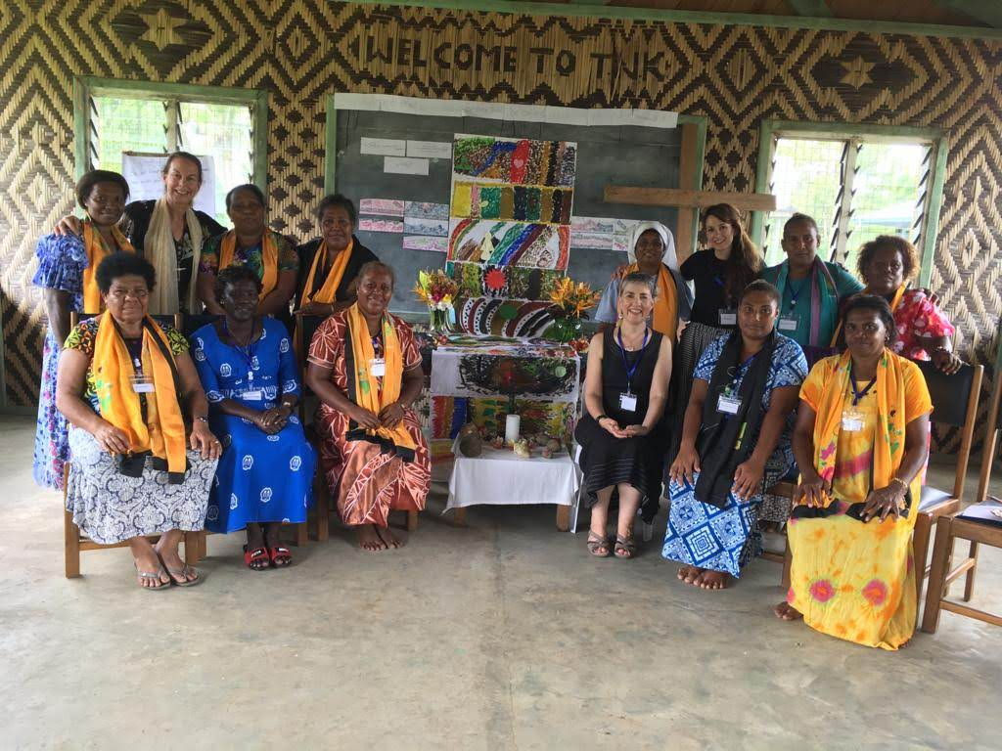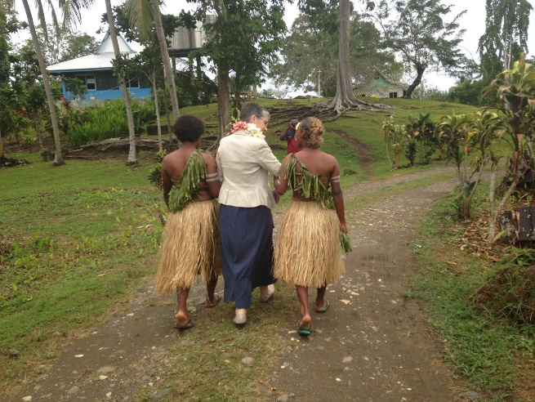

The Lambeth Conference in July 2020 will bring together 500 or so bishops plus spouses from across the Anglican Communion. This is our diocese’s opportunity to strengthen mission work across the Communion and to make the Communion real for people (especially women) in other continents. We can make a difference both to senior Anglican women in conflict-stricken areas and to community groups in Tanzania. Advent is the season of hope, and we can share some of this delightful virtue with others.

Please do support my appeal.

With every blessing,

+Robert Gibraltar in Europe

