St Michael’s Messenger
MAY 2024

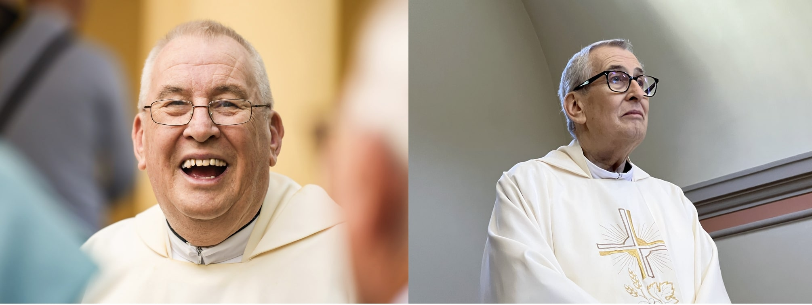
fr TONY ingham’S funeral
Hearts were heavy and tears flowed as more than 150 members of the St Michael’s
community filled the church on the cold and sunny morning of Tuesday 23 April to say their farewells and pray for the soul of Fr Tony Ingham, who passed away at home in
Beaulieu on 15 April with his wife Fiona at his side. The Funeral service, led by Fr Hugh of St Paul’s Monaco, was preceded by a family vigil on Monday evening at the church. Fiona’s grief, that of the family and of the many life-long friends present, was shared by the entire congregation.

Among those in attendance were the Mayor of Beaulieu-sur-Mer, Roger Roux, members of the clergy including Helen Innes, representing her husband, Bishop in Europe Robert Innes, Archdeacon Peter Hooper, The Ven Stephen Robbins CB QHC, former Chaplain General to the British Army and his wife Lydia, Fr Philip Robinson, Fr Patrick Springford and his wife Carole, Chaplains of Nice, Marseille and Menton as well as a former Priest in Monaco. Père Irek of the local Roman Catholic church was also present, as were nuns from the
Little Sisters of the Poor in Nice and a number of lay people from other congregations on the Riviera.

After the service, the Funeral cortege moved to the Nice Crematorium for the rites of
committal attended by the family. After the cortege moved away, refreshments were served in the Church garden, ending a deeply sad, but also joyous occasion to celebrate
Fr Tony and Fiona’s remarkable service to St Michael’s church and our community.

- Editor Eric
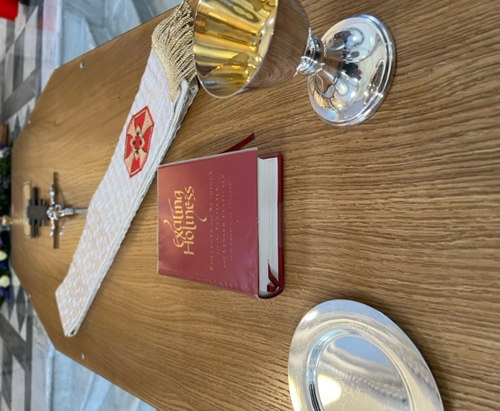
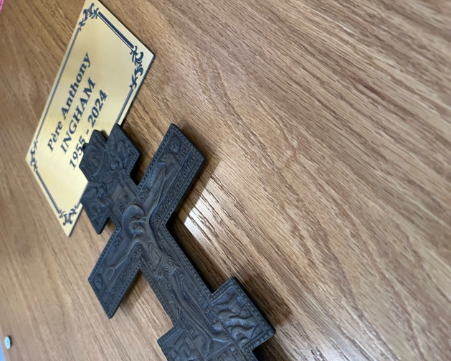
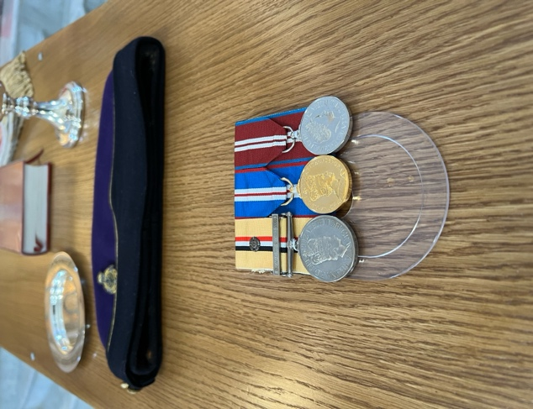
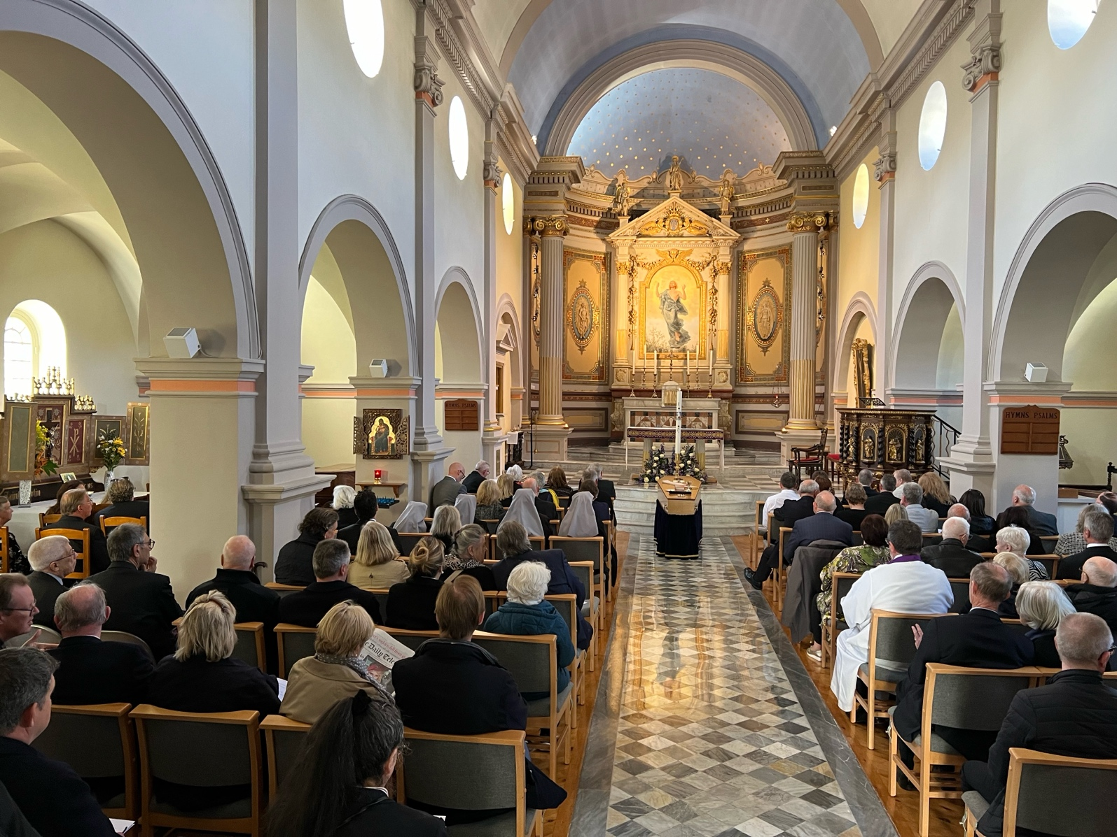
Personal symbols of Fr Tony’s priesthood and military service were arranged on the coffin:
crucifix, stole, prayer book, paten, chalice, forage cap and medals

First to speak at the service was Fr Stephen, no stranger to St Michael’s. As Fr Tony’s
commanding officer during his service as a military chaplain in Iraq, Fr Stephen
recalled how Tony’s deep training as a clergyman gave him a special quality of empathy and the readiness to minister to any and all service personnel, no matter their background.

The Funeral Oration, quoted in full below, was given by Fr Hugh:

“When we discussed today’s service and the arrangements around it, Tony was very keen to make sure that the Gospel reading was at its very centre. These were for the most
obvious of liturgical reasons, but it also struck me as so apposite for a man whose entire life was centred on the Christian Gospel. The words of Jesus found on its pages, the
example he has left us to follow and the resurrection hope, moulded Tony into the man we knew him to be, and he lived out that faith throughout the years that God had given him. There is so much to be thankful for in the life of this man`s life whose mortal remains lie before us today and whose memory we treasure.

Tony Ingham was a faithful and hardworking priest, devoted to Fiona and their family and a loyal friend. His sense of humour was almost legendary, and as we sit in this Church, many of us we can bring to mind occasions when his delivery of a simple “one liner”
resulted in side-splitting laughter. He had a remarkable ability to see the absurd in life, and, in his gentle manner, convey it to those around him. There was not the slightest whiff of cant about Tony, he was unsanctimonious, unpretentious, grounded in his Lancastrian roots, not given to flights of fancy nor in any way, a self-publicist. Tony had a sharp and incisive mind. His miniature toy soldier collection, that he constructed and painted in their thousands, reflected his passion for history. He was informed, analytical and intelligent and his bookshelves reflected his theological outlook and understanding.

Tony was perceptive and possessed the well-tuned, practiced skill and gracious kindness of a true Christian priest, in ministering to whoever was in front of him at any given time and responding to their need, notwithstanding. As has been stated elsewhere, he was also nobody’s fool. It would be very wrong to imagine that he was a passive bystander. He was not afraid to challenge what was wrong, and did so methodically and calmly. He had a
loving and generous heart and along with Fiona, Tony took the Christian obligation of
hospitality very seriously. There are many people who have been enriched by their
kindness over a good meal. I am reminded of Ecclesiastes chapter 3 verse 13, “I am sure that it is God`s gift to man, that everyone should eat and drink and take pleasure in his toil.”

Well, he did exactly that. He fixed a mean Gin and Tonic, aka “rocket fuel” that will hard to replicate! Tony was even handed and generous both with his time and his talents. He could always be relied upon to respond, no matter how inconvenient it might be for him
personally. There were numerous pastoral situations in which he simply said, “yes,” whether rushing some poor chap to an eye hospital or giving time for counselling and a
listening ear. Over the last week or so people have shared stories about how he did this along the Riviera that could be replicated in all the places in which he served.

However, Tony wasn’t a “yes man” and in his gentle way, he could challenge the faithful, whether priest or lay. As a wise and mature man of faith and example he was able to be an authentic voice helping others to trust in God`s love and not to be frightened. Someone once coined the expression in this regard with the words, “We need to be a bit more Tony.” Perhaps that is true of us all.

Before he died and when he was still conscious Tony`s hands were anointed with the holy oils as is appropriate for a priest. Yesterday, when his coffin was brought into this Church, the articles and embellishments of that servant role were placed upon it. The Cross, the
Bible, the chalice and paten and his stole. Next to these are his medals and his forage cap reflecting his duty to his country and the Crown. Tony Ingham was a man of integrity,
decency and honesty, consistent and dependable, a deeply prayerful man. These are a few of his attributes; but what made him such an effective servant of Jesus, and without any shadow of doubt whatsoever, was the simple fact that God had gifted to all of us who knew and loved him, a very decent human being. And that very decent human being was only able to live as he did, because the Christian Gospel was at the very centre of his life. Tony did not fear death and held the unshakable conviction in God`s love in eternity, what we call heaven.

Someone from England contacted me a few days ago and, in their words, remarked that, “A bright and gentle light has gone out.” In one sense this is true, but in another it is not. Tony said that death was the start of another grand adventure, and this was not
sentimental nonsense which he would have none of as we know. The lenses of faith through which he approached his death were focussed upon the Biblical promises of
Jesus, sound theology, the teaching of the Church and the unchanging Christian hope into which Tony was baptised. Tony wanted the Christian Gospel to be at the centre of this
service because it was at the centre of his life; he would want that to be true of us as well.

Anthony William Ingham, a good and faithful servant of Jesus Christ, his Risen Lord.
At peace and at rest.”

Amen
- Fr Hugh

.***

Order of Service

The Order of Service for Fr Tony's Funeral is reproduced on St Michael’s YouTube channel:

https://youtu.be/7XocaVvxPKg

The music is "Highland Cathedral", which was piped as Tony left the church. It is
performed here by the Central Band of the Royal British Legion.

From the Diocese of Europe (link)

Obituary of Father Tony Ingham | Diocese in Europe (anglican.org)

Condolences sent to The Messenger

The news of Fr Tony’s passing inspired many members of the St Michael’s community to email compassionate responses and messages of condolence. Here are some of them:
​
“He was a true man of God and it was a privilege to know him.”

“He was a very special person with such a positive outlook, dedication and so much to give to St Michael’s community. He is and will be greatly missed. Our thoughts and prayers are with Fiona and all of the family.”

“He and I went back a long way. May he rest in peace and rise in glory.”

“Fiona and Father Tony have been a wonderful team together. My love and condolences to Fiona, the family and the whole community. Fiona will be in my thoughts and prayers. May Father Tony Rest in Peace.”

“May Father Tony rest in peace and May God give Fiona the necessary courage in her
grief. 🌸 “’

“I share your grief.”

“Our hearts are with Fiona.”

“My sincere condolences to Fiona and the family, may Fr Tony rest in peace.”

“It has been a great joy to meet Father Tony and cooperate with him for the Danish
congregation. We share your grief.”

“I have so much to thank Father Tony and Fiona for - their kindness and support. I well
remember the amazing support and encouragement given us during the pandemic and lock-down period, with such thoughtful videos sent us to keep our spirits up, and the lovely Zoom get
togethers and sermons and wisdom in the newsletters. What incredible, amazing and self-sacrificing support. And so essential during that period. I am sure each of us has been touched deeply, as I have been, and been very blessed by Father Tony and Fiona's ministry during their years at St Michael’s. I will keep Fiona in my thoughts and prayers at this extremely difficult time, and the times to come.”

“We know Father Tony is in a place that he has always wanted to be: with his creator and Lord. But it is so sad for all of us, and for Fiona.”

“Prayers go out to Fiona 🙏”

“Father Tony’s love for his Saviour, and the (wider) congregation he served so faithfully, shone brightly for all to see on our Christmas visits to beautiful BSM. Memories to treasure. A race well run. Our prayers are with you all, and especially Fiona and family. God bless you all.

“The entire congregation of St. Michael's will be in my thoughts and prayers. May the peace of Christ which passeth understanding abide with you always.”

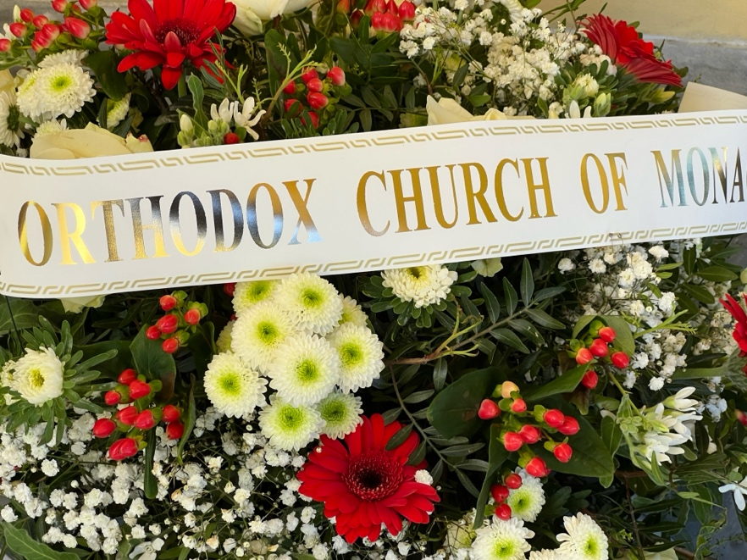
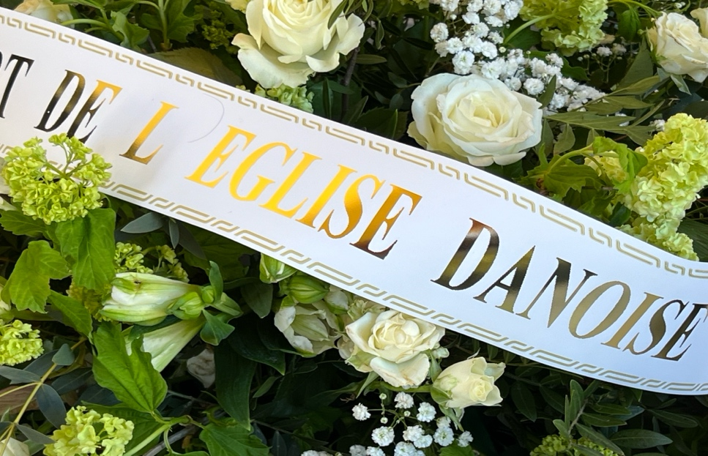
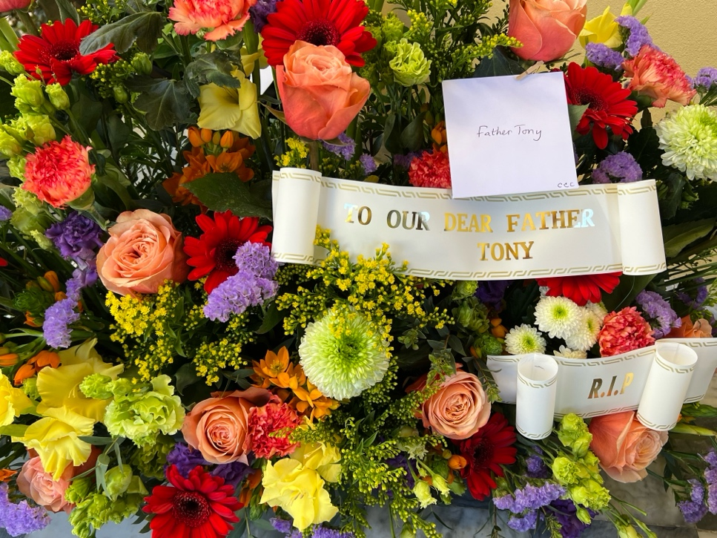
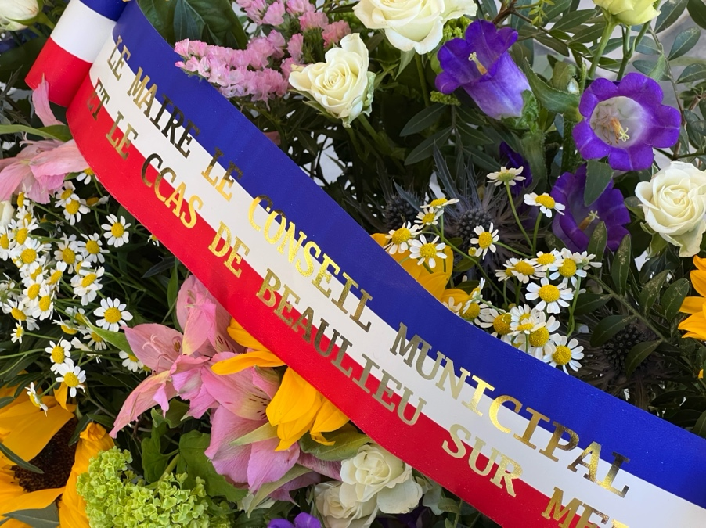

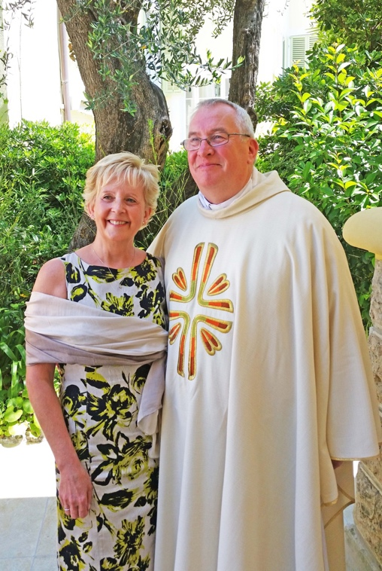

May Father Tony rest in peace and rise in glory.
May God bless Fiona, the families and friends.

***

Diary Dates April-May 2024

Saturday 27 April CCC Visioning Meeting with Archdeacon Peter Hooper

Sunday 28 April 10h00 – Eucharist – Easter 5 (St Mark – Feast)
Led by Archdeacon Peter Hooper
Readings: 1. Proverbs 15: 28-33 https://www.biblegateway.com/passage/?search=Proverbs+15%3A+28-33&version=NIV
2. Ephesians 4: 7-16 https://www.biblegateway.com/passage/?search=Ephesians+4%3A+7-16+&version=NIV
AGM - Annual General Meeting, following the service
Chaired by Archdeacon Peter Hooper

Sunday 5 May 10h00 – Eucharist – Ascension
Readings: 1. Acts 1: 1- 11 https://www.biblegateway.com/passage/?search=Acts+1%3A+1-+11&version=NIV
2. Ephesians 1:15-23 https://www.biblegateway.com/passage/?search=Ephesians+1%3A15-23&version=NIV

Sunday 12 May 10h00 – Eucharist – Easter 7
Readings: 1. Acts 1: 15-17, 21-26 https://www.biblegateway.com/passage/?search=Acts+1%3A+15-17%2C+21-26&version=NIV
2. 1 John 5: 9-13 https://www.biblegateway.com/passage/?search=1John+5%3A+9-13&version=NIV

Wednesday 15 May CCC Meeting

Sunday 19 May 10h00 – Eucharist – Pentecost
Readings: 1. Acts 2:1-21 https://www.biblegateway.com/passage/?search=Acts+2%3A1-21&version=NIV
2. Romans 8:22-27 https://www.biblegateway.com/passage/?search=Romans+8%3A22-27&version=NIV

Sunday 26 May 10h00 – Eucharist – Trinity
Readings: 1. Isaiah 6:1-8 https://www.biblegateway.com/passage/?search=Isaiah+6%3A1-8&version=NIV
2. Romans 8:12-17 https://www.biblegateway.com/passage/?search=Romans+8%3A12-17&version=NIV

Thursdays at 18h30 Exercise and Relaxation

Fridays at 19h00 Pentecostal Service in French

***

Annual Meeting 2024

The Annual Chaplaincy Church Meeting (ACCM) of the Association Cultuelle of St
Michael’s Anglican Church, Beaulieu-sur-Mer will take place immediately following the
Eucharist on Sunday, 28 April in the church.

The Annual Meeting will be chaired by Archdeacon Peter Hooper and will address any questions members may have about Church of England procedures for the Locum period and the search for a new minister. All members of the congregation who are entered in the Electoral Roll are encouraged to attend.

- CCC Secretary Nancy
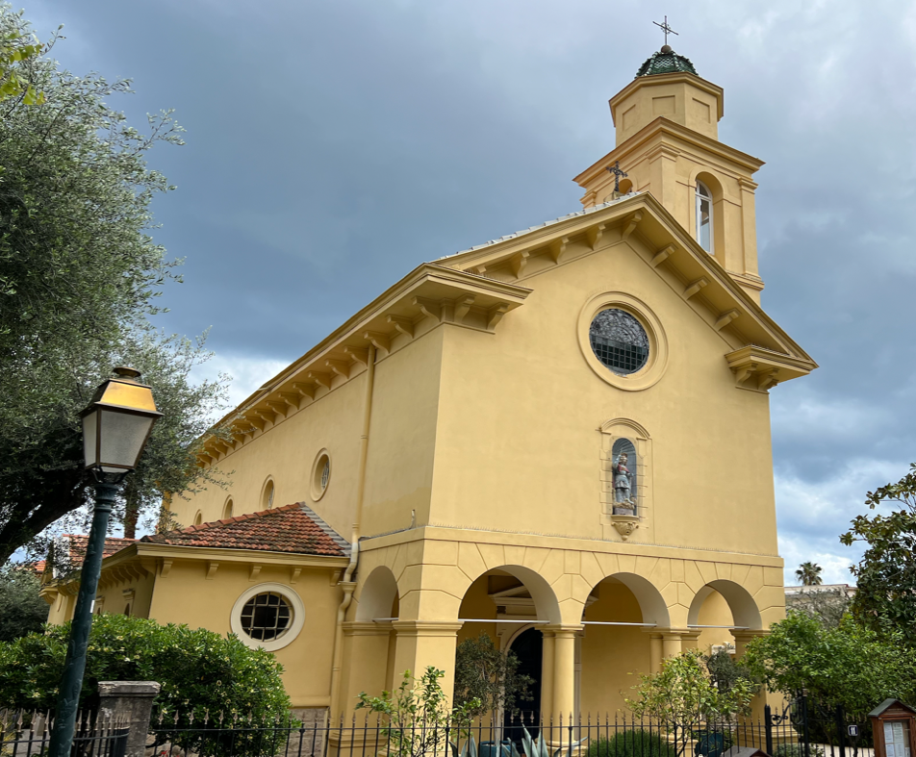

***
Want to get in touch?
Editor Eric: stmichaels-messenger@outlook.com
Webmaster Hugh: info@stmichaelsbeaulieusurmer.org
Our Website: www.stmichaelsbeaulieusurmer.org

Disclaimer: The editor and St Michael's Church do not accept responsibility for the consequences of any action taken upon the advice, advertisement or information contained in The Messenger.

