Ein Bild, das Text, Whiteboard enthält.

**RACIAL JUSTICE FOLLOW-UP CONFERENCE**

**ALL of us or NONE of Us**

***Redesigning the Ecumenical and Inter-faith landscape***

***for a Racially Just, Radically Inclusive and Healing Community***

**December 4th to 7th 2024**

**Evangelische Akademie Bad Boll, Germany**

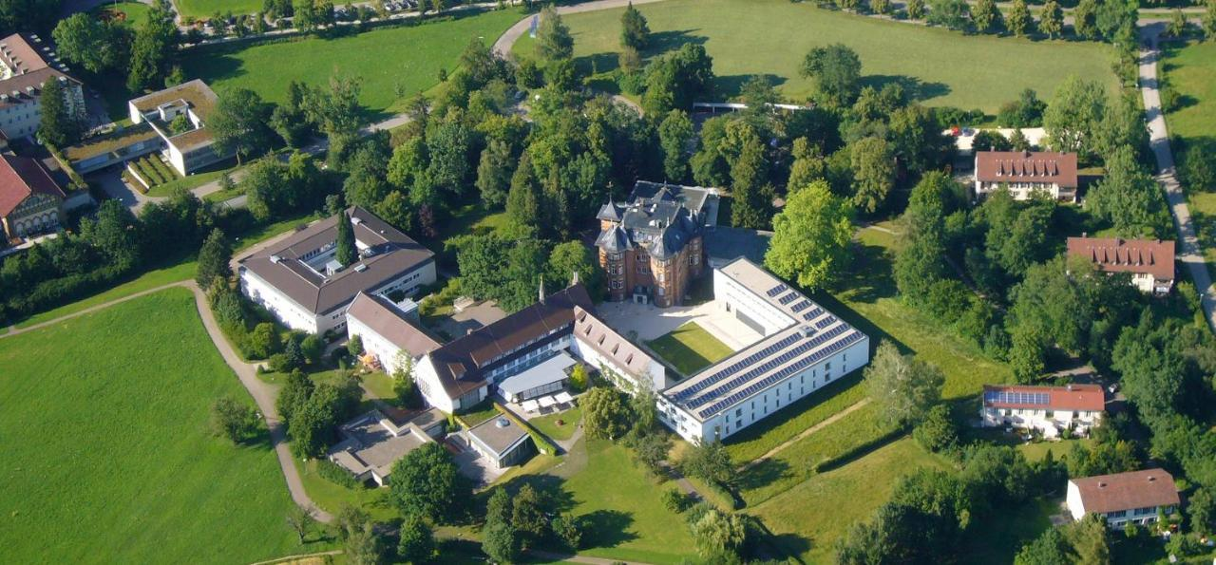

**Conference and Accommodation Registration Form**

ONLINE SUBMISSION POSSIBLE – SEE LINK IN PART E

Participants at the conference must be aged 18 or over. However, any younger person can attend with an appropriate/approved chaperone (this information will be shared with the Conference safeguarding team).

Participants must arrange their own visas where these are needed. The Conference coordinators will be able to provide letters of invitation once your attendance has been confirmed.

**Part A**

Family Name

|  |
| --- |
|  |

Middle Name



|  |
| --- |
|  |

First Name

|  |
| --- |
|  |

Age/ Date of Birth

|  |
| --- |
|  |

Mobile Number with country code

|  |
| --- |
|  |

Email for communication

|  |
| --- |
|  |

Details of Chaplaincy or Organisation

|  |
| --- |
|  |

City and Country of Chaplaincy or Organisation

|  |
| --- |
|  |

Details of engagement and interest in the area of Racial Justice and Inter faith initiatives

|  |
| --- |
|  |

Expected Time of Arrival in Bad Boll

|  |
| --- |
|  |

Expected Time of Departure from Bad Boll

|  |
| --- |
|  |

**Part B**

**Food and Accommodation**

The Conference Fee is Euros 450 which includes 3 nights accommodation on 4,5,6 December

This accommodation will be in the Conference venue or close by.

The Included meals will be:

Breakfast, Lunch and Coffee on 5,6,7 December

Dinner (except drinks) on 4, 5 and 6 December

Separate arrangements will have to be made if extension of stay is planned.

All participants who require the Conference to book accommodation are requested to kindly share the following information:

Occupancy preferred (single or twin room)

|  |
| --- |
|  |

If a twin room is requested, participants may indicate who they want to share the room with.

|  |
| --- |
|  |

Would additional night bookings be required? (these are at an extra cost)

|  |
| --- |
|  |

Dietary requirements

|  |
| --- |
|  |

Any additional information

|  |
| --- |
|  |
|  |

Emergency contact information (mobile and email)

|  |
| --- |
|  |

Participants may arrange their own accommodation but a contribution/registration fee of 150 Euros per person is required to cover registration and lunches on 5,6,7 December plus coffee/tea expenses during the conference. Dinner will be an extra charge.

**Bursaries:** Funds are being sought for bursaries to help participants who are least able to cover their own costs. If you would like to attend but require bursary support to assist you please give some details of your circumstances here:

|  |
| --- |
|  |

**Part D**

**Conference Payments**

Please submit this form **as soon as possible** so that arrangements can be put in place in good time. The latest date for registration is September 25, 2024.

As informed in Part B, the costs for accommodation and food are 450 Euros. This amount will need to be paid shortly after the Registration is approved to secure the bookings.

All payments should be made in-full electronically in Euros to the account below with an email confirmation to the Conference Secretary, Molly Catherine,

Email: racialjusticeconference@gmail.com

**Account Information: (for online payment of conference fee)**

**Bank:** Commerzbank Bonn

**Account name:**F.A.C.B.C. e.V. (stands for Friends of the Anglican Chaplaincy Bonn and Cologne)

**IBAN:** DE56 3804 0007 0255 5571 00

**(all payments must be clearly marked as towards the Racial Justice Conference with the name of the participant clearly indicated)**

**Part F**

By registering for the conference, participants agree that footage of the conference (Photo, video and/or audio) may be taken, stored and used for legitimate purposes, in particular public relations work and documentation, by the organisers or other participants. Please alert the conference organisers if you have any objection to this.

For participants from outside Germany we recommend to actively ensure that their travel insurances, in particular health, accident and third party liability, cover all potential costs. The organisers’ liability for damage is restricted to intent and gross negligence in exercising their duties.

Part E

Signature

|  |
| --- |
|  |

Please forward the completed Registration Form to the Conference Secretariate at [racialjusticeconference@gmail.com](mailto:racialjusticeconference@gmail.com) at the earliest and not later than September 25, 2024.

It could be submitted online using the link

<https://racial-justice-registration-form.odoo.com/survey/start/13847eaf-d107-4af9-9877-da5733e1127d>

Please Note: All the participants are invited to join the Carol Service at St. Catherine’s Stuttgart at 5 pm on Saturday the 7th of December and have a stroll around the famous Christmas Markets of Stuttgart after the same. However they will have to make their own arrangements for accommodation in Stuttgart if they stay chose to do so. Extending the stay in the Evangelische Academy in Bad Bol which a centre of healing and relaxation is also a possibility for which separate arrangements with the venue would have to be made.