****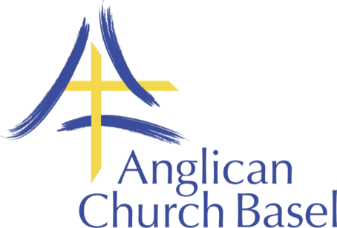

**Job Description: Youth and Children’s/Families’ Worker**

The Anglican Church in Basel (ACB) is an international English-speaking church that is part of the Church of England Diocese in Europe. It has evangelical roots and builds on the whole range of traditions in the Church of England, as well as drawing in people from a wide range of other nationalities and denominations living in and around Basel.

ACB’s Children’s and Youth Ministry includes Sunday and mid-week mission and ministry for all young people and children from baby upwards. One expression of God’s Kingdom is enabling family life to flourish. We would like to continue developing this ministry in the English-speaking (including English as a second language) community in the “Dreiländereck” region.

**Purpose:**

* To lead and develop ACB’s mission and ministry sharing Christ’s love and growing disciples among and through children, youth and families in the “Dreiländereck” region.

**Objectives:**

* Develop and promote a vision for children, youth and families’ ministry at ACB
* Lead, build and manage a motivated and engaged Children’s Ministry Team
* Lead and work with the Children’s ministry team to provide regular Sunday teaching classes at both the morning and evening services
* Develop and promote a Youth Ministry Team
* Provide weekly Youth Group sessions
* Provide ad-hoc mid-week and weekend activities for Children Youth and Families
* Provide outreach and discipleship opportunities during holiday periods (e.g. Easter and part of the school summer holidays).
* Ensure a safe working environment in accordance with the CofE safeguarding guidelines

**Employed by**: Council of the Anglican Church in Basel.

**Reporting to**: Chaplain of the Anglican Church in Basel

**Working directly with**: Clergy Team, Children’s Ministry leaders and helpers

**Frequency and duration of the position**: 50-60% post (to be discussed with candidate).

**Remuneration**: this is a salaried post at an amount to be agreed

**Minimum length of appointment:** 2 years

**Trial period**: 6 months